

Catch Up Funding Strategy Statement 2020-21
School | St Marks Academy | School Strategy Leader | Jennie Khan
No. of Eligible Pupils |  | Total Allocation
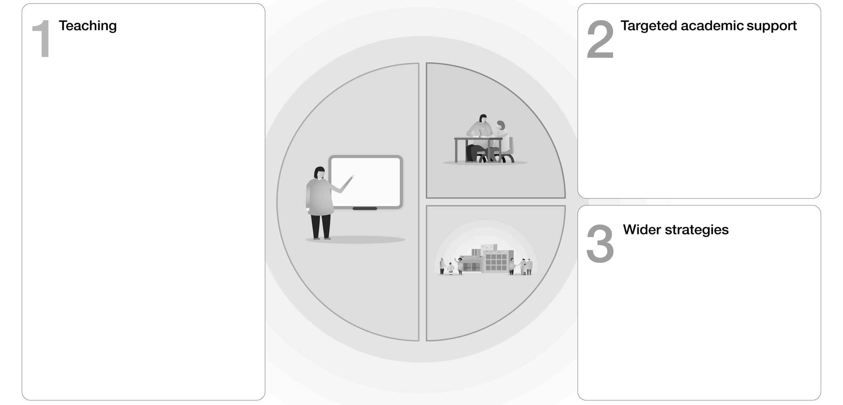

One to one and small group tuition
- Have been approved for Catch-Up Academic Mentor programme in Maths/Humanities
- Applied for more information on National Tutoring Programme; application made to the 16-19 Fund
Intervention programmes
- Continued focus on Year 7 Catch-up for those not making expected progress in English/Maths (see Year 7 Catch up Strategy)
- Attendance intervention support for all year groups including EWO/Family Liaison
- SEND intervention to support engagement/progress
Extended school time
- Year 11 sole use of library from 3.30 to 5.00pm for study support
Supporting Great Teaching
- High Quality CPD for all staff, with a weekly programme linked to school priorities and line management foci.
- Teacher development tracked using PASPro to monitor pedagogy, share best practice and support where areas of concern arise
- Middle leadership focus on Curriculum planning and responding to engagement data from lockdown
- Additional Breakfast CPD for BT, NQT and NQT+1
Pupil Assessment & Feedback
- Blended Learning Approach including regular exit ticket quizzes testing to identify gaps and measure progress.
- Low stakes testing used in lessons to constantly monitor student progress
- GL progress tests for core subjects to monitor progress of students and explore where intervention might be needed.
- Revision Guides and study resources purchased for Year 11.
Transition support
- Summer School held in August 2019 for vulnerable students
- Virtual transition portal including taster lessons created for Year 6 into Year 7
- CATS/Reading/Spelling tests used in first 2 weeks to gather data to support effective teaching and intervention,

Supporting Parents & Carers
- Exploring use of online parents evening systems to ensure effective dialogue on student progress
- Letters sent home to Year 7 parents with guidance on how to support with reading
Access to Technology
- Year 7 laptop pilot in Summer 2020 to be reviewed by AEL
- Software being explored to support with KS4 Home Learning e.g Focus on Sound
Summer Support
- Summer School held in August 2019 for vulnerable students

Eligible Pupils include Year Reception – Year 11
Allocations will be calculated on a per pupil basis, providing each mainstream school with a total of £80 for each pupil in years reception through to 11.

