SIXTH FORM PREFECTS 2024

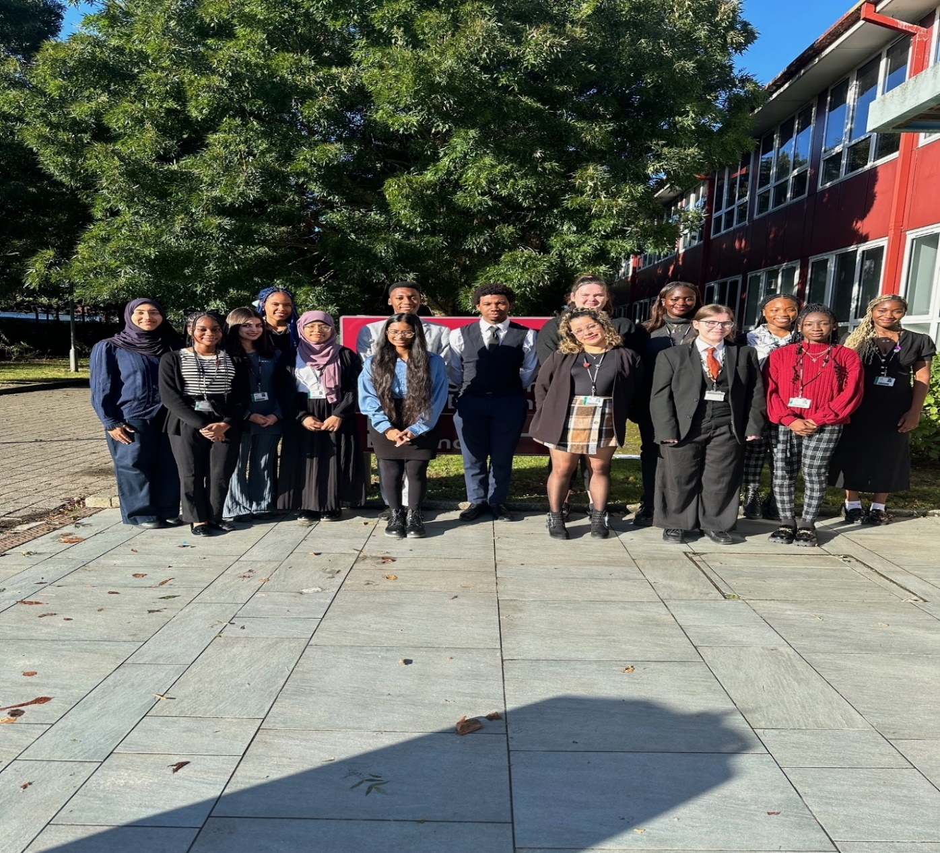

**Head Prefects**  **Senior Prefects** **Prefects**

Daniella Titiriku Triumph Egbonim-Onyenike Emma Bwanswa,Fabia Santos, Aslhey Obama

Amarachi Onyemaechi Athalia Nartey-Thompson Zahra Rashid, Sarniya Muralitharan,

Grace Enoch, Imaan Richarson,

Zhila Bakhtiari, Julia Pascoal Iago Santiago

Tomiwa Daniels